Executive Summary
The SwiftFulfil Executive Operations Dashboard provides a consolidated overview of business performance across sales, customers, products, suppliers, and revenue trends over a twelve-month reporting period.
The analysis was conducted using a relational MySQL database, SQL queries for business intelligence, and Microsoft Excel to develop an executive dashboard suitable for operational reporting. The objective was to transform transactional data into meaningful insights that support strategic decision-making by senior management.
During the reporting period, SwiftFulfil generated £957,926.16 in total revenue from 1,000 customer orders, serving 623 customers with 9,286 units sold, resulting in an average order value of £957.93.
Revenue remained relatively stable throughout the reporting period, although fluctuations indicate periods of stronger and weaker commercial performance that warrant further investigation. Product sales are distributed across multiple categories, with Fitness representing the largest revenue contributor (25%), followed by Home & Kitchen, Office Supplies, Electronics, and Accessories. This suggests that revenue is diversified rather than concentrated within a single product category.
Geographical analysis indicates that revenue is generated across several cities, with Birmingham, Edinburgh, and Leeds contributing the highest sales values. Customer segmentation also demonstrates a balanced revenue distribution between Standard, Premium, and Enterprise customers, reducing commercial dependence on any single customer segment.
Supplier analysis identifies a number of strategically important suppliers contributing significant revenue and offering broad product portfolios. Understanding supplier contribution and product coverage provides opportunities to strengthen supplier relationships while reducing operational dependency on individual vendors.
During the project, a significant data quality issue was identified within the shipment dataset. Shipment dates frequently occurred before their corresponding order dates, producing impossible fulfilment durations. Rather than manipulating the source data to produce expected results, fulfilment-time analysis was excluded from the final business conclusions. This demonstrates the importance of validating source data before presenting operational KPIs.
Overall, the dashboard provides senior management with a concise, evidence-based view of commercial performance while highlighting opportunities for continued growth, supplier optimisation, and improved data governance.

Business Problem
Modern e-commerce organisations generate large volumes of transactional and operational data from customers, products, suppliers, orders, and fulfilment activities. While this data is valuable, it often exists in raw or fragmented forms that make it difficult for senior management to monitor business performance and make informed strategic decisions.
Without structured analysis, organisations may struggle to identify high-performing products, understand customer purchasing behaviour, evaluate supplier performance, or recognise emerging business trends. Furthermore, poor data quality or inadequate validation can result in inaccurate reporting, leading to ineffective operational and commercial decisions.
The objective of this project was to address these challenges by designing a relational database, analysing operational data using SQL, and developing an executive dashboard that transforms raw transactional data into meaningful business intelligence. The project aims to provide decision-makers with clear, evidence-based insights into sales performance, customer behaviour, product performance, supplier contribution, and overall business trends.
Throughout the analysis, particular emphasis was placed on validating the integrity of the underlying data before drawing business conclusions. During this process, inconsistencies were identified within the shipment data that rendered fulfilment performance metrics unreliable. Rather than presenting misleading operational KPIs, the issue was documented and excluded from the final analysis, demonstrating the importance of data governance and analytical integrity in business reporting.
The resulting analysis provides a comprehensive view of organisational performance while illustrating the complete analytics lifecycle—from database design and data validation to executive reporting and strategic recommendations.

PROJECT OBJECTIVES and scope
The primary objective of this project was to design and implement an end-to-end operations analytics solution capable of transforming raw operational data into meaningful business intelligence for senior management.
To achieve this objective, the project aimed to:
- Design and implement a relational MySQL database capable of storing operational data relating to customers, products, suppliers, orders, and shipments.
- Prepare, validate, and integrate multiple datasets to ensure the quality and integrity of data used for business analysis.
- Develop SQL queries to calculate key business performance indicators and analyse trends across revenue, customers, products, suppliers, and geographical locations.
- Identify high-performing products, customer segments, suppliers, and sales trends that contribute most significantly to business performance.
- Assess the quality of operational data and document any integrity issues that could affect the reliability of analytical findings.
- Develop an executive dashboard in Microsoft Excel that presents business performance in a clear and accessible format for strategic decision-making.
- Translate analytical findings into evidence-based business insights and strategic recommendations that support informed operational and commercial decisions.
This project focuses on sales, customer, product, supplier, and revenue analysis using transactional data stored within a relational MySQL database. Operational fulfilment analysis was initially included within the project scope; however, following data validation, inconsistencies within the shipment data rendered fulfilment-time metrics unreliable. Consequently, fulfilment performance analysis was excluded from the final business conclusions to maintain analytical integrity.

DATA SOURCE, PREPARATION and DATABASE DESIGN

Data Source
The SwiftFulfil Operations Analytics project was developed using a synthetic dataset designed to simulate the operational environment of a medium-sized e-commerce fulfilment company. As the project was created for portfolio and learning purposes, no real customer or organisational data was used.
The dataset was generated using Python to produce realistic operational records representing customers, suppliers, products, orders, shipments, warehouses, employees, and supporting reference data. The use of synthetic data ensured that the project could replicate real-world business scenarios while maintaining data privacy and eliminating the use of personally identifiable information.
The Faker Python library was used to generate realistic customer names, addresses, email addresses, telephone numbers, company information, and geographical data. This provided representative business data while ensuring consistency across the dataset.
Following data generation, the Pandas library was used to structure the datasets into DataFrames, perform data preparation activities, validate record structures, and export each dataset as CSV files. These CSV files formed the source data for the relational database implemented in MySQL.
The completed dataset consisted of multiple related tables representing the core business functions required for operational analysis, including customers, products, suppliers, orders, order items, shipments, warehouses, employees, departments, and product categories.

Database Design
A relational database was designed and implemented in MySQL to support efficient storage, retrieval, and analysis of operational business data. The database was structured using normalised tables linked through primary and foreign key relationships, ensuring referential integrity and reducing data redundancy.
The relational design enables complex SQL queries across multiple business domains, including customer behaviour, sales performance, product analysis, supplier performance, and operational reporting.
The database architecture reflects the relationships commonly found within an e-commerce fulfilment organisation and provides a scalable foundation for business intelligence and decision support.

Entity Relationship Diagram (ERD)
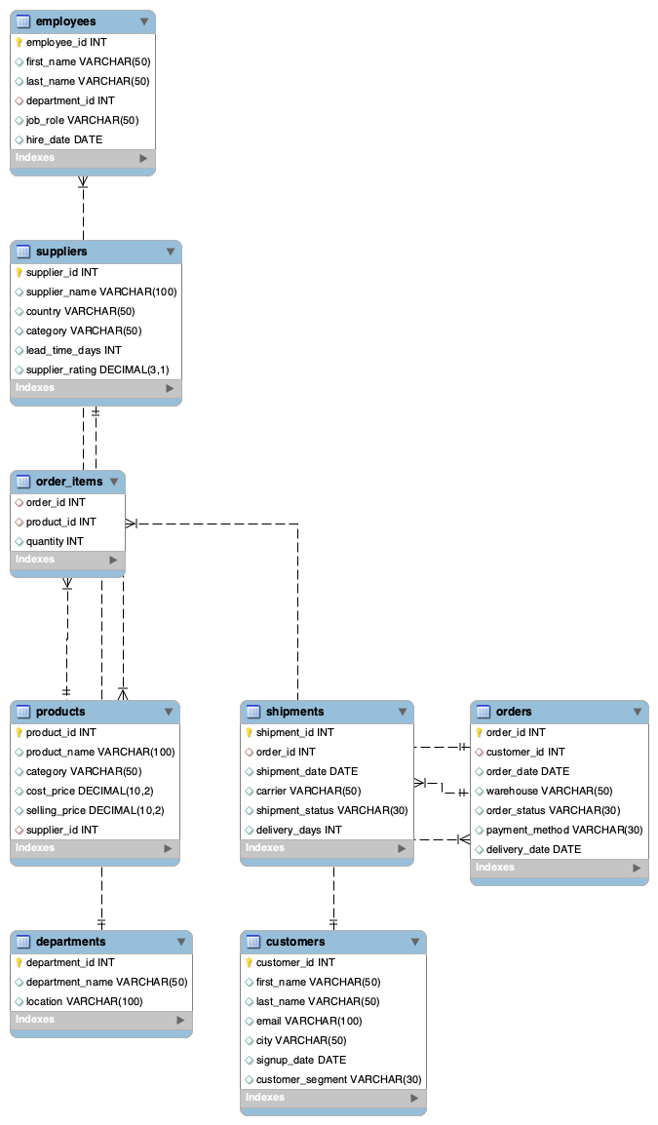
Figure 1. Entity Relationship Diagram illustrating the relationships between the tables within the SwiftFulfil relational database.

The database was designed using a relational model centred on customer orders. Customers place orders, each order contains one or more products through the order_items table, products belong to categories and suppliers, and shipment records track order fulfilment. Supporting tables such as warehouses, departments, and employees provide additional operational context. This structure minimises data redundancy and enables efficient SQL queries across multiple business domains.

Database Schema

Table | Purpose
Customers | Stores customer information, demographics, and customer segment details used for customer analysis and segmentation.
Orders | Records customer purchases and order dates used for sales and trend analysis.
Order_Items | Stores individual products associated with each customer order, enabling product-level revenue analysis.
Products | Contains product information including category, supplier, and selling price.
Categories | Defines product categories used for revenue and product performance reporting.
Suppliers | Stores supplier information used for procurement and supplier performance analysis.
Shipments | Records shipment details associated with customer orders for fulfilment analysis.
Warehouses | Stores warehouse information supporting logistics operations.
Employees | Employee reference data included within the operational database structure.
Departments | Department reference data supporting organisational reporting.

Database Development Workflow

Synthetic Data Generation (Python + Faker)
│
▼
Data Preparation & Validation (Pandas)
│
▼
CSV Dataset Export
│
▼
MySQL Relational Database
│
▼
SQL Business Analysis
│
▼
Executive Dashboard (Excel)
│
▼
Business Insights & Strategic Recommendations

Data Dictionary
The data dictionary provides a summary of the principal tables within the SwiftFulfil relational database, including their key fields, descriptions, and business purpose. This documentation supports understanding of the database structure and demonstrates how each table contributes to the analytical objectives of the project.
Table | Key Fields | Description | Business Purpose
customers | customer_id (PK), customer_name, city, segment, signup_date | Stores customer demographic and account information. | Customer segmentation, geographic analysis, customer growth, lifetime value analysis.
orders | order_id (PK), customer_id (FK), order_date, warehouse_id (FK) | Records customer purchase transactions. | Revenue analysis, order trends, customer purchasing behaviour.
order_items | order_item_id (PK), order_id (FK), product_id (FK), quantity | Stores individual products purchased within each order. | Product sales analysis, revenue calculation, units sold.
products | product_id (PK), product_name, category_id (FK), supplier_id (FK), price | Stores product catalogue information. | Product performance, pricing, category analysis.
categories | category_id (PK), category_name | Defines product categories. | Revenue by category, product portfolio analysis.
suppliers | supplier_id (PK), supplier_name | Stores supplier information. | Supplier performance and dependency analysis.
shipments | shipment_id (PK), order_id (FK), shipment_date | Records shipment details for customer orders. | Intended for fulfilment analysis (excluded due to data integrity issues).
warehouses | warehouse_id (PK), warehouse_name, city | Stores warehouse information. | Warehouse reporting and operational context.
employees | employee_id (PK), department_id (FK), employee_name | Stores employee reference information. | Organisational structure (not analysed in this project).
departments | department_id (PK), department_name | Stores department reference information. | Organisational reporting (not analysed in this project).

Dashboard Analysis

Executive KPI Overview
The executive KPI cards present a high-level summary of overall business performance. During the reporting period, SwiftFulfil generated £957,926.16 in revenue across 1,000 orders, serving 623 customers and selling 9,286 units. The average order value of £957.93 provides an indication of customer purchasing behaviour and establishes a baseline for future performance comparisons.

Revenue Trend
Monthly revenue demonstrates relatively stable performance throughout the reporting period, with noticeable peaks during September 2025 and January 2026 and a decline towards December 2025. The business recovered following this period, suggesting either seasonal demand patterns or successful commercial activity during the first quarter of 2026.
Management should continue monitoring monthly trends to improve forecasting accuracy and better understand seasonal purchasing behaviour.

Revenue by Category
Revenue is distributed across five primary product categories.
Fitness contributes the highest proportion of total revenue (25%), followed closely by Home & Kitchen, Office Supplies, Electronics, and Accessories. The relatively balanced distribution suggests the organisation benefits from a diversified product portfolio, reducing reliance on any individual category.
This diversification helps reduce commercial risk while providing opportunities for targeted investment in high-performing product lines.

Revenue by City
Sales are generated across multiple cities, with Birmingham producing the highest revenue, closely followed by Edinburgh and Leeds.
Although revenue differences between locations are relatively small, the analysis enables management to identify regional performance differences and support targeted marketing or expansion initiatives.

Customer Segment Performance
Revenue generated from Standard, Premium, and Enterprise customers is remarkably balanced, with each segment contributing approximately one-third of total revenue.
This balanced customer mix indicates healthy diversification and reduces dependency on any single customer segment. It also suggests opportunities to develop tailored retention strategies for each customer group.

Top Products
The Top Products analysis highlights the products generating the greatest revenue during the reporting period.
Monitoring product performance enables management to prioritise inventory availability, optimise promotional activity, and negotiate favourable supplier agreements for high-demand products.

Supplier Performance
Supplier revenue analysis identifies the organisations contributing the highest commercial value.
Understanding supplier contribution supports procurement planning, contract negotiations, and supplier relationship management while reducing operational risk associated with supplier dependency.

Supplier Product Offerings
The Product Offerings by Suppliers visualisation illustrates the breadth of products supplied by each supplier.
This analysis provides additional operational context beyond revenue alone by identifying suppliers offering the widest product portfolios. Combining revenue contribution with product diversity enables management to assess supplier importance from both commercial and operational perspectives.

Strategic Recommendations
Based on the analysis, the following recommendations are proposed for senior management:

1. Prioritise High-Performing Categories
Increase investment in product categories demonstrating the strongest revenue contribution while continuing to monitor emerging category trends.

2. Strengthen Inventory Planning
Use historical sales trends and top product analysis to improve demand forecasting and reduce stock shortages for high-performing products.

3. Develop Supplier Strategy
Review supplier dependency by considering both revenue contribution and product portfolio breadth. Strategic suppliers should be prioritised for long-term partnerships and performance reviews.

4. Expand Regional Opportunities
Investigate the commercial practices driving stronger performance in leading cities and evaluate whether similar approaches can be implemented in lower-performing locations.

5. Maintain Balanced Customer Growth
Continue developing tailored engagement strategies across Standard, Premium, and Enterprise customer segments to preserve the balanced revenue profile while improving customer lifetime value.

6. Improve Data Governance
Address inconsistencies within shipment records by implementing stronger validation controls during data collection. Reliable operational data is essential for accurate fulfilment reporting and performance measurement.

